Lab 25: Operational Amplifiers I
Introduction
We begin work this week on analog electronics with an examination of the behavior of the LF356 general purpose op-amp. I remind you of the basic operation of an op-amp.
1) (Golden Rule 1) The inputs draw no current. (Always true, always useful.)
2) (Golden Rule 2) When negative feedback is present and working, the output voltage adjusts itself so that V+ = V-. (True only when negative feedback is working, useful then.)
3) Vo = G (V+ - V-) where G is very large number: for the 356 typically 200,000. (Always true, very rarely useful!)
And, from energy conservation considerations, the output voltage is limited to stay well within the power supply voltages. With a +15V power supply you will be lucky to get +14V maximum from the output of the chip.
NOTE 1: As usual, there are lots of different complete chip names. They might say LF356 or LF356CN or something else. If you have an 8-pin chip with the 356 surrounded by any set of letters then it is the chip you want!
NOTE 2: Thanks to some very effective standardization, every model of op-amp that comes one in an 8-pin package uses the same pin-out. You can rely on power being 7 & 4, inputs 3 &2, and output on pin 6. Because this leaves some pins leftover, there is also a standard for putting TWO op-amps in a single 8-pin package so you do have to be little careful.
1) Open-Loop behavior
Open-loop means without feedback so that golden rule 2 will NOT hold and we will see the underlying behavior of the amplifier.
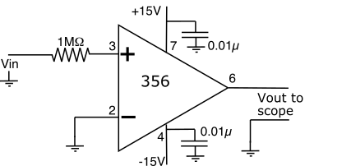

Connect up the circuit on left on your designer. Be careful hooking up the capacitors, they regularly cause people problems.
FIRST connect pins 7 and 4 to the +ve and –ve power supplies. SECOND add the capacitors, one from pin 7 to ground and one from pin 4 to ground.
Vin should come from your Instek signal generator set to produce a <0.1V P-P sine waves at about 100Hz.
a) Predict the output voltage from the circuit.
The output voltage should be a square wave with a little less than 30V peak-to-peak. This is because the open loop gain of the op-amp is high enough that even a tiny positive voltage should be amplified to its maximum output.

b) Display Vin on channel 1 and Vout on channel 2. Paste an image of what you see below.
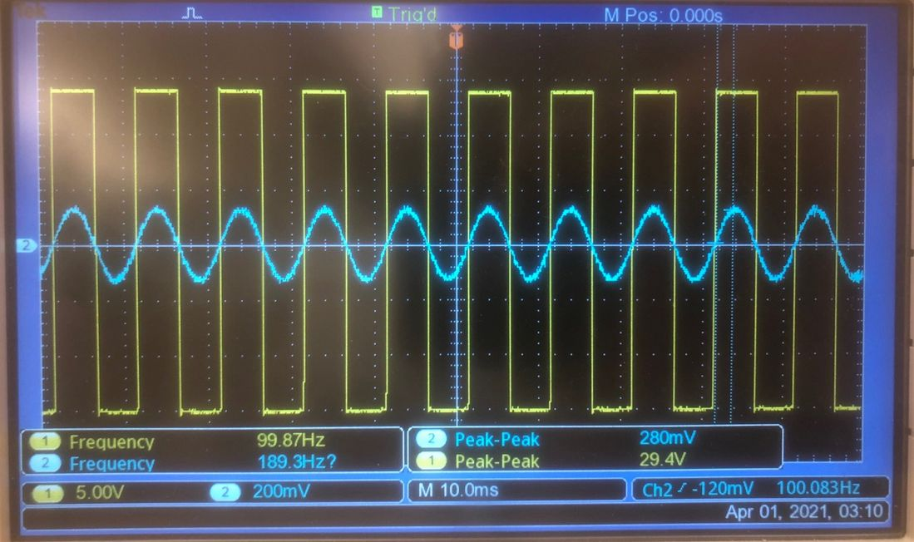

c) Explain in detail how this output is roughly consistent with the expected behavior for the op-amp.
This is consistent with the expected behavior of the op-amp.

d) Measure the voltage drop across the 1M input resistance and thus measure the input current. Comment on the validity of Golden Rule 1.
There is no measurable voltage drop across the 1M resistor. Thus, the input current is also very small, so Golden Rule 1 holds.

2) Closed-loop behavior 1, the non-inverting amplifier
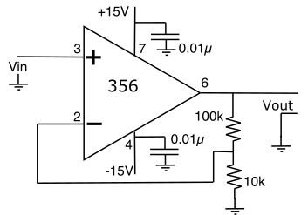

An operational amplifier is said to operate in a closed loop when there is feedback taken from the output to the input (usually the inverting input) of the amplifier. When we apply the feedback to the negative input (negative feedback) we trade a vast reduction in the gain of the amplifier for a major improvement in the properties of the amplifier. Indeed, the behavior of the overall circuit comes to depend only upon the passive components in the feedback loop and not at all on the (imperfect) properties of the amplifier.
The figure on the left shows a standard, single op-amp, non-inverting amplifier as described in chapter 21.
a) Predict the gain of this op-amp using the values of the resistors given in the figure.
The gain of the op-amp should be 11.

b) Modify your previous circuit to get this circuit. Connect one channel of your oscilloscope to the output and one to the non-inverting input. Provide a sine wave input signal at 1kHz with a pk-pk amplitude of about 0.1V from your signal generator. Paste an image of the input and output waveforms on the graph below.
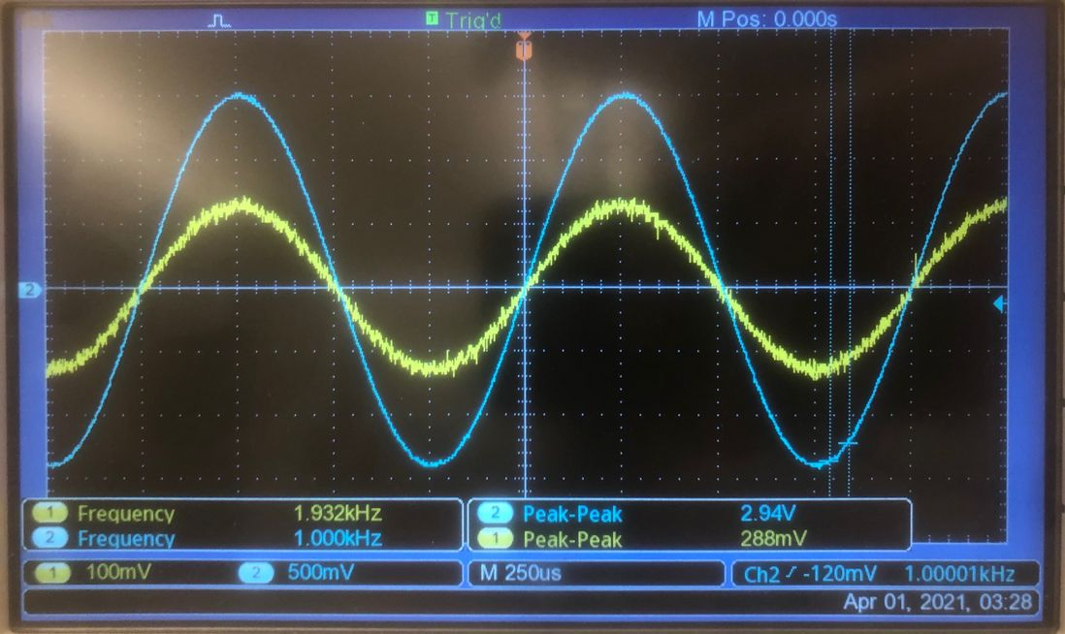

c) Measure the input and output voltage magnitudes as accurately as you can. How is the output related to the input? Please be as quantitatively accurate about the gain as possible.
The output voltage is 10.21 times the input voltage.

d) Compare this to your prediction.
Because the input signal is noisy, we would expect its peak-to-peak voltage to be read a little higher than it should, so it is expected that the gain would be a little less than 11.

e) Predict the effect on the gain of the system if you swap the 10k and 100k feedback resistors.
If the resistors were swapped, then the gain would be 1.1.

f) Measure the gain with the resistors swapped and compare the value to your prediction, taking into account resistor tolerance.
After swapping the resistors, the measured gain was 280mV / 260mV = 1.077. The resistors have a 5% tolerance, so it is possible that the 10k resistor has a little less resistance than advertised and the 100k resistor has a little more resistance than advertised. This is likely the reason that the observed gain is less than 1.1.

g) What is the minimum gain possible from this amplifier configuration (you can change the resistor values not their positions)?
The minimum possible gain is very close to 1. If R2 has very little resistance, then the R1 + R2 is only slightly greater than R1, so the gain is close to 1.

3) Closed-Loop behavior II, the Buffer
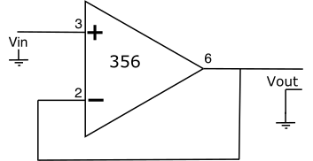
A common special case of the non-inverting amplifier is the unity-gain buffer shown to the left.
I remind you also that although power supplies, and their associated filter capacitors, will not usually be shown on the diagrams (as I did not here), they are ALWAYS required (the law of conservation of energy says so).

a) Predict the gain of this circuit using the golden rules.
By Golden Rule 2, the gain of this circuit should be 1.

b) Adjust the resistors to make your circuit match this circuit and measure its gain.
Vout = Vin, so the gain is 1.

This seems at first like a rather pointless circuit. However, it is actually a very useful circuit as the following example will show.
c) First disconnect the signal from your Instek from the amplifier and connect it to channel 1 of you scope. Set the signal to be a ~0.3 V P-P sinewave at 500 Hz.
d) What do you see (please measure the amplitude carefully)?
The amplitude is 268mV P-P.

e) Now connect the Instek signal to your loudspeaker, keeping the connection to the oscilloscope. Now, what do you hear?
I hear a very quiet sine wave.

f) Look at the signal on the speaker with you scope and remeasure the amplitude.
36.8mV

g) Explain the difference using the fact that the speaker has a resistance of about 8Ω and you know the output impedance of the Instek.
The Instek signal generator has an output impedance of 50Ω. Thus, the measurement agrees with the theory, since (8/58) * 268 = 36.966.

h)
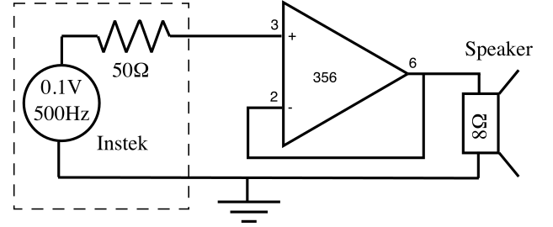

Now insert the unity-gain buffer between the output of the computer and the speaker (figure, left).
Remember, you still need the power connections to the op-amp!!!!
Repeat the experiment and describe what you see and hear this time, including the measured output voltage.
The output voltage is 252 mV, and the speaker is a little louder.

i) Explain the difference and so explain the role of the buffer amplifier. In particular talk about the input and output impedances (resistances) of the amplifier and what kind of gain this amplifier does exhibit.
The amplifier, which draws no current, is connected to the output of the signal generator. Thus, there’s no voltage drop caused by the output impedance of the signal generator. Since the amplifier ensures that its output voltage matches its input voltage, we don’t see the voltage drop from before, and the sound is amplified.

